**Tweaks**

If you’re rotating your ship and hold the control key (ctrl) then it will snape to certain angles.

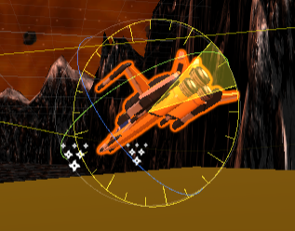

If your terrain goes dark or slows down every time you make a change turn off your Auto Generate lighting. This will also help with the terrain going dark bug.

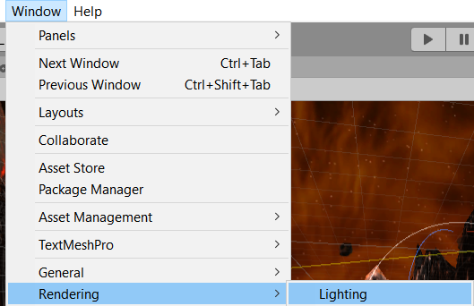

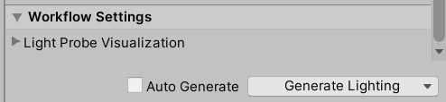

1. Lets move all the asset packs to one folder. Create a folder called **Asset Packs** and move all your asset packs in here.

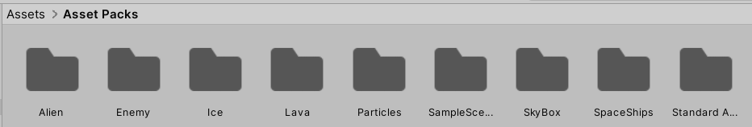

1. Create a **Scenes** folder and place your splash screen and level 1 in here.
2. Make a prefab out of **explosion** particles.
3. Make a folder called **Materials** and place any colors you’ve created in here.
4. Make a folder for **Prefabs** and place your **Bullets**, **Explosion** particles in there. Your **landing pad** and **Spaceship**.
5. Make an **Audio** folder and place your music and sound effects in here.
6. Make a **Scripts** folder and place code in there.
7. Make a folder called **Environment** for your **skybox** and **terrain**

Prefabs

1. Go to your **Splash** scene
2. Lets prefab the **Music Player**
3. Lets move to the other scene. Rename **Directional Light** to **Sun Light** and prefab it.
4. Make the obstacles prefabs

Scripts

1. Open the **MusicPlayer** script. The fact that its responsible for loading the next scene is weird. Lets create a new script named **SceneLoader**.
2. Go back to the **Splash** scene
3. Create an **Empty GameObject** and name it **Scene Loader**. Reset its position. Attach the new **SceneLoader** script to it.
4. Move this loadscene code to the LoadScene Script. 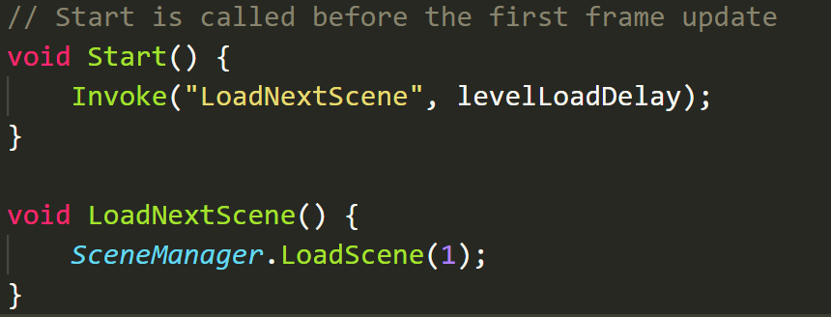
5. **DON’T FORGET THE IMPORT and levelLoadDelay variable**

using UnityEngine.SceneManagement;

[*SerializeField*] float levelLoadDelay = 2f;

1. Delete the **Update** method from **MusicPlayer** since we don’t need it. Your **MusicPlayer** should be left with just your **Awake** method.
2. Create 30 seconds of rail time
3. Try rotating the camera during turns on your timeline to add a cool effect